SE Lab Mini Project

Group – 2

Name | Roll No. | Registration No.
- Aakarsh Jha | 39 | 230905248
- Shreyan Raghuvanshi | 38 | 230905247
3. Hemanth Raj Vardhan |  | 230905538

Certificate

This is to certify that the mini-project entitled LLM-based DevSecOps Platform for Proactive Security Analysis, is a bonafide record of the work done by the following students:
- Aakarsh Jha
- Hemanth Raj Vardhan
- Shreyan Raghuvanshi
in partial fulfillment of the requirements for the course Software Engineering Lab (SE LAB) as part of the curriculum for the Bachelor of Technology in Computer Science and Engineering.
This project was successfully completed during the Fifth Semester in October 2025.

Abstract

This project focuses on the development of an automated DevSecOps platform leveraging Large Language Models (LLMs) to enhance code security early in the development lifecycle. The primary objective is to create a tool that analyzes code commits in real-time before deployment, effectively detecting and preventing security bugs from entering the deployment phase.
The system is designed for seamless GitHub integration, where any commit or push automatically triggers an LLM-powered vulnerability scan. The LLM engine is specifically engineered to spot common security risks, such as SQL injection, Cross-Site Scripting (XSS), and unsafe data handling. This approach automates the security review process, providing developers with quick, proactive feedback on potential risks, helping them write safer, cleaner code without slowing down their workflow.
Upon detection, a security report is generated. This ensures that security issues are remediated without significant disruption to the continuous integration and delivery (CI/CD) workflow.

Table of Contents

➢ Introduction
➢ Problem Statement
➢ SRS
➢ Use Case, Class, Collaboration, Activity, Sequence ,State cart, Package and
Deployment Diagrams
➢ Implementation of Code
➢ Developed GUI
➢ Results and Analysis
➢ Conclusion
➢ References

Introduction

Modern software is built fast using processes like CI/CD (Continuous Integration and Continuous Delivery). This speed is great, but it often means security checks get pushed to the end, or are skipped entirely. The goal of DevSecOps is to fix this by making security a continuous part of the whole development process, not just a final step. We need a way to check code for security problems right when the developer is writing it.
This project is about building a simple DevSecOps platform that uses a Large Language Model (LLM) to find security issues. Our tool integrates directly with GitHub. When a developer pushes code, the LLM analyzes it immediately to catch common security errors before the code is merged. The aim is to give developers fast feedback so they can write safer, cleaner code without slowing down their work.

Problem Statement

In many development environments, security checks are a bottleneck or happen too late. This project addresses the following issues:
- Late Bug Discovery: Security bugs are often found late, sometimes only after the code is deployed. Fixing a bug late is much harder and more expensive than fixing it early.
- Slow Security Reviews: Manual security checks or using slow scanning tools interrupt the developer's momentum. This discourages developers from prioritizing security.
- Vulnerable Code Slips Through: There is a risk that code with known flaws, like SQL injection or XSS, gets merged into the main repository and deployed.
- Clunky Tools: Traditional tools can flag too many issues (false positives), causing developers to ignore security warnings (alert fatigue).
Our solution is to develop a tool that uses an LLM to analyze code in real time before it is deployed. This tool will detect security bugs early, preventing vulnerable code from ever entering the final deployment. This involves creating a workflow that provides proactive security checks as an essential part of the development cycle.

Software Requirements Specification

for

LLM DevSecOps

Prepared by: Aakarsh Jha, Shreyan Raghuvanshi, Hemant Raj Vardhan

Organization: Manipal Institute of Technology

Table of Contents

1.Introduction
1.1 Purpose
1.2 Document Conventions
1.3 Intended Audience and Reading Suggestions
1.4 Product Scope
1.5 References

2. Overall Description
2.1 Product Perspective
2.2 Product Functions
2.3 User Classes and Characteristics
2. 4 Operating Environment
2.5 Design and Implementation Constraints
2.6 User Documentation
2.7 Assumptions and Dependencies

3.External Interface Requirements
3.1User Interfaces
3.2Hardware Interfaces
3.3Software Interfaces

System Features (Functional Requirements)
4.1Code Ingestion and Pipeline Triggering
4.2LLM-Powered Security Analysis
4.3Security Report Generation and Feedback
4.4Database Management and Provenance

5.Other Nonfunctional Requirements
5.1Performance Requirements
5.2Security Requirements
5.3Reliability and Availability Requirements
5.4Business Rules

6.Appendices
Appendix A Glossary
Appendix B Analysis Models
Appendix C To Be Determined List

1.Introduction

  - Purpose
The main purpose is to build a tool that automatically reviews source code using LLMs to spot security problems instantly. Our core objective is simple: stop bad code from being merged into the main project repository and deployed. We want to give developers quick, helpful feedback so they can write safer code without slowing down their fast development schedule. This document lists all the features and technical standards needed to build this tool.

  - Document Conventions
This document strictly follows the IEEE 830 standard conventions for requirement specification, ensuring clarity and precision for all stakeholders. All requirements have unique numbers (e.g., R-4.2.1) for easy tracking.

Requirement Priority and Conventions
Convention | Description
Requirement Numbering | RX.Y.Z (Section X, Sub-section Y, Requirement Z) for explicit traceability.
Priority Levels | H (High): Essential for MVP and core operation; M (Medium): Important enhancement or compliance feature; L (Low): Future scope or desirable feature.
Report Format | Generated security reports must be available in machine-readable JSON format and human-readable Markdown format.

  - Intended Audience and Reading Suggestions
This SRS is the main guide for everyone working on LLM-DSO. The audience includes:
- Developers: They need to implement the LLM engine and the GitHub integration.
- Project Managers: They oversee the schedule and need to meet the September 15, 2025, deadline.
Security Engineers & QA: They test the system to ensure it accurately finds vulnerabilities (Sections 4.2 and 5.2).

  - Product Scope
The LLM-based DevSecOps Platform is an automated security check that runs within the GitHub workflow. The project scope includes:
- Integrating seamlessly with GitHub for scanning code whenever a developer pushes changes.
- Developing the LLM engine to find key vulnerabilities (SQL injection, XSS, unsafe data handling).
- Creating structured security reports and giving instant feedback to the developer.
- Creating mandatory documentation, including a Software Flowchart and an Entity-Relationship (ER) diagram.

  - References
This specification uses the following documents and standards:
- IEEE 830 Standard for Software Requirements Specifications.
- Project reports detailing the use of Large Language Models in DevSecOps.
- Documentation related to mandated LLM services, including Google AI Studio, ChatGPT, and Claude AI.
- Industry guidelines for CI/CD pipeline security, including OWASP best practices.

2. Overall Description

  - Product Perspective
The LLM-DSO acts as an automated Security Guard inside the development pipeline (CI/CD), specifically running checks after a developer commits code but before they merge it. It is triggered by tools like GitHub Actions and talks to external LLM services (like Google AI Studio) to analyze the code. Unlike older security tools that only look for patterns, our LLM-DSO uses the LLM's advanced understanding to find complex bugs and, more importantly, write specific code suggestions to fix them (R-4.2.4). While the scan runs briefly, it must save a permanent record of every security alert found for tracking and auditing.

  - Product Functions
The system follows four main steps for every code change:
- Code Ingestion: The system is triggered by GitHub (a push or a Pull Request update) and retrieves only the new code differences (diff) for analysis.
- Intelligent Analysis: The LLM engine sends the code diff to a mandated LLM (like ChatGPT) to identify and classify security flaws (e.g., SQLi) and assign a severity rating.
- Report Generation: It creates two reports: a machine-friendly JSON report (for the CI/CD Quality Gate R-5.5.1) and a human-readable Markdown report (for the developer).
- Feedback and Persistence: It immediately posts the Markdown report as a comment on the GitHub Pull Request and saves the JSON report to the central database for history.

  - User Classes and Characteristics

The system serves three main groups:
User Class | Description | Interaction Requirements and Needs
Developer (Primary User) | Writes code and receives the security feedback. | Needs very fast feedback (R-5.1.1) delivered directly into the GitHub PR comment section.
Security Analyst/Admin | Manages security rules and audits past vulnerabilities. | Needs access to the database (Bug Report, Security Alert) to see trends, track fixes (R-4.4.2), and create compliance reports (R-4.4.3).
CI/CD Pipeline (System Actor) | The automated environment (e.g., GitHub Actions) that runs the tool and decides if the code can be merged. | Requires reliable API calls and structured, predictable output (JSON) to enforce the pass/fail Quality Gate.

  - Operating Environment
LLM-DSO runs in a cloud CI/CD environment. The service itself is packaged using Docker containers. Key external connections are to the GitHub platform, the CI/CD orchestrator (like GitHub Actions), and the mandated Large Language Model APIs (Google AI Studio, ChatGPT, Claude AI). A dedicated database is needed for storing all security reports permanently.

  - Design and Implementation Constraints
The project must follow these strict limitations:
- Mandatory Tools: We must use Google AI Studio, ChatGPT, and Claude AI for the security analysis, and the system must integrate with GitHub and VS Code. This means we need a component (R-3.3.2) to easily switch between these different AI services.
- Speed: The security check must be fast ("real-time") and cannot interrupt the developer's work. We have specific time targets to meet (R-5.1.1, R-5.1.2).
- Privacy (Source Code): Since we send our project code to external LLMs, we must ensure the LLM providers do not log or use the code for training their models.

  - User Documentation
The project must include documentation for users and administrators:
- Developer Integration Guide: How to set up the LLM-DSO trigger in GitHub Actions (including example code).
- API Specification: Details on the internal API used by the CI/CD pipeline.
- System Administration Manual: How to manage LLM API keys and view reports in the database.

  - Assumptions and Dependencies
The system depends on external services to work:
- External API Availability: We assume the mandated LLM APIs (Google AI Studio, ChatGPT, Claude AI) are stable enough to meet our 99.9% availability goal (R-5.3.1).
- API Rate Limit Management: We assume we can manage the call limits from the LLM providers using smart caching (R-5.1.5) and our abstraction layer (R-3.3.2) to prevent the service from failing.
- GitHub Reliability: GitHub must be consistently available to trigger scans and provide code access.

3. External Interface Requirements

3.1 User Interfaces
Developers primarily interact with the system through existing GitHub tools.
- R-3.1.1 (H): The main interface for developers must be the GitHub Pull Request Comment or Console Output.
- R-3.1.2 (H): The security report posted to GitHub must use Markdown formatting to clearly show the severity, bug type, and the exact line number where the problem was found.

3.2 Hardware Interfaces
The system runs entirely on cloud servers.
R-3.2.1 (H): The LLM-DSO service must be delivered as a portable Docker container so it runs the same way on any CI/CD runner.

3.3 Software Interfaces
Since we use multiple LLM providers, structured integration is mandatory.
- R-3.3.1 (H): GitHub API: The system must use GitHub Webhooks to start the scan and the GitHub REST API to read code changes and post comments.
- R-3.3.2 (H): LLM Abstraction Layer: A dedicated component must be built to handle the differences between the Google AI Studio, ChatGPT, and Claude AI APIs. This layer manages keys, standardizes data, and handles provider-specific throttling.
- R-3.3.3 (H): Database Interface: The system must use a secure driver to store data persistently according to the schema defined in the ER Diagram (Appendix B).

4. System Features ( Functional Requirements)

4.1 Code Ingestion and Pipeline Triggering
- R-4.1.1 (H): The system must automatically start the security analysis when a developer creates or updates a Pull Request on GitHub.
- R-4.1.2 (H): The system must only retrieve and process the changed code files (diff) instead of the entire project to ensure fast feedback (R-5.1.1).

4.2 LLM-Powered Security Analysis
The core function is using the LLM to intelligently analyze the code.
Target Vulnerability Classes for LLM Detection
Requirement ID | Vulnerability Class | Priority | Description
R-4.2.1 | SQL Injection (SQLi) | H | Find code where user input is used unsafely in database queries.
R-4.2.2 | Cross-Site Scripting (XSS) | H | Find places where un-sanitized data is shown to the user, potentially allowing malicious scripts.
R-4.2.3 | Unsafe Data Handling | H | Flag issues like sending data without encryption (non-TLS) or storing credentials insecurely.
R-4.2.4 | Remediation Guidance | H | For every bug found, the LLM must suggest a specific, corrected code block to help the developer fix it quickly.
R-4.2.5 | Hardcoded Credentials | M | Scan for passwords or API keys stored directly in configuration or source code (R-5.2.2).
- R-4.2.6 (H): The LLM must give every security finding a severity rating: Critical, High, Medium, or Low. This rating is mandatory for the Quality Gate (R-5.5.1).

4.3 Security Report Generation and Feedback
- R-4.3.1 (H): The system must generate a full report in JSON format, which is required by the CI/CD pipeline for automated decisions.
- R-4.3.2 (H): A separate, easy-to-read report using Markdown must be generated for display on the GitHub Pull Request comment.
- R-4.3.3 (H): Both reports must clearly contain the unique alert ID, the file path, the exact line number, and the fix suggestion (R-4.2.4).

4.4 Database Management and Provenance
The system must keep a history (System of Record) of all security issues found, tracking User, Repository, Bug Report, and Security Alert entities.
- R-4.4.1 (H): All generated Security Alerts and Bug Reports must be saved permanently in the central database, linked to the code Repository and the submitting User.
- R-4.4.2 (M): Security Analysts must be able to update the status of an alert (e.g., "Fixed," "False Positive") for historical tracking.
- R-4.4.3 (M): The system must allow administrators to query the database to generate simple compliance reports (e.g., list all open High-Severity bugs).

5. Other Non-Functional Requirements

5.1 Performance Requirements
Since the tool must be "real-time" and not slow down the development workflow, we have strict speed targets.
LLM Analysis Performance Metrics
Metric | Requirement (95th Percentile) | Priority | Justification
End-to-End Pipeline Latency (E2E) | Max 30 seconds per standard commit analysis | H | Ensures the system finishes its check fast enough for CI/CD flow.
Time to First Token (TTFT) | $\le$ 500 ms | H | Developer needs immediate confirmation that the LLM analysis has started.
Inter-Token Latency (ITL) | $\le$ 50 ms (Average) | H | Ensures the full report and fix suggestion are generated quickly.
System Throughput (Concurrency) | Support 5 concurrent analysis jobs | M | Required minimum capacity for a small development team.
- R-5.1.5 (H): The system must use smart caching (e.g., Redis) to remember results from previously scanned files or libraries to reduce redundant, slow LLM API calls.

5.2 Security Requirements
We must protect our own source code while we scan it.
- R-5.2.1 (H): Authentication: All communication with the LLM-DSO service must be secure, typically using service accounts or tokens.
- R-5.2.2 (H): Secret Management: Sensitive data, like LLM API keys and database passwords, must never be hardcoded. They must be stored in a secure system (e.g., Azure Key Vault) and accessed only when needed.
- R-5.2.3 (H): Data Privacy and IP Protection: The system configuration must be set up to prevent the external LLM providers from logging, retaining, or using the submitted source code fragments for training. This is critical for protecting the project's intellectual property.

5.3 Reliability and Availability Requirements
- R-5.3.1 (H): Availability: The LLM-DSO service must be available 99.9% of the time during working hours.
- R-5.3.2 (M): Fault Tolerance: The system must handle LLM API failures gracefully, using a Circuit Breaker pattern to manage repeated errors and using retry logic before marking an analysis job as failed.
- R-5.3.3 (M): Monitoring: We must use centralized logging to track performance (R-5.1.1) and quickly diagnose any failures in the pipeline.

5.4 Business Rules
These rules dictate how the system influences the development workflow.
- R-5.5.1 (H): Quality Gate Enforcement: If the LLM-DSO finds any vulnerability rated as Critical or High severity (R-4.2.6), the CI/CD pipeline must fail, and the Pull Request must be blocked from merging until the issue is fixed.
- R-5.5.3 (L): Usage Quotas: The system should track token usage for all external LLM services to help control API costs.

6. Appendices

Appendix A: Glossary

Term | Definition
CI/CD | Continuous Integration/Continuous Deployment: The automated pipeline for building, testing, and deploying software.
DevSecOps | Integrating security practices throughout the entire software development lifecycle (SDLC).
LLM-DSO | LLM-based DevSecOps Platform: The subject system of this SRS.
LLM | Large Language Model: The AI model used for contextual code analysis and vulnerability pattern recognition.
TTFT | Time to First Token: The latency measure for the time taken to generate the first output token from the LLM.
ITL | Inter-Token Latency: The average time taken to generate successive tokens after the first.
Quality Gate | An automated checkpoint (R-5.5.1) that blocks a code merge if quality standards are not met.

Appendix B: Analysis Models

The following analysis models are mandatory deliverables for the LLM-DSO project, providing structural definition and behavioral context.
- Entity-Relationship (ER) Diagram:
  - The diagram must show the relationship between the core data entities: User, Repository, Bug Report, and Security Alert.
  - Relationship: The User submits code to a Repository. The system generates a Bug Report which contains multiple Security Alerts.
- Software Flowchart (Operational Steps):
  - This diagram details the required steps: Developer writes code Code is pushed to GitHub CI/CD triggers DevSecOps checks LLM-based engine scans for vulnerabilities (R-4.2) Security Report (JSON/Markdown) is generated (R-4.3) Report is sent to developer Quality Gate checks status (R-5.5.1) End.
- Hardware Flowchart (Infrastructure Flow):
  - This model shows the infrastructure interactions: Developer's commit GitHub CI/CD runner LLM-DSO service performs analysis using external LLM services (Google AI Studio, ChatGPT, Claude AI) Output (PR comments) and data persisted to Database.

Appendix C: To Be Determined List

These items need to be decided later:
- Final LLM Selection: Which specific LLM (e.g., Gemini Pro, GPT-4) will be used in production after testing.
- Database Technology: Final choice between SQL (PostgreSQL) or NoSQL (MongoDB) for alert persistence.
- Advanced Ticket Integration: Detailed requirements for connecting to external bug trackers like JIRA.

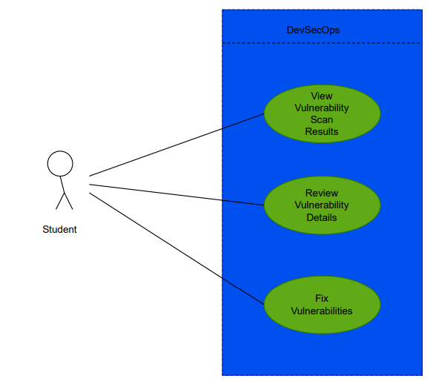
Use Case Diagram

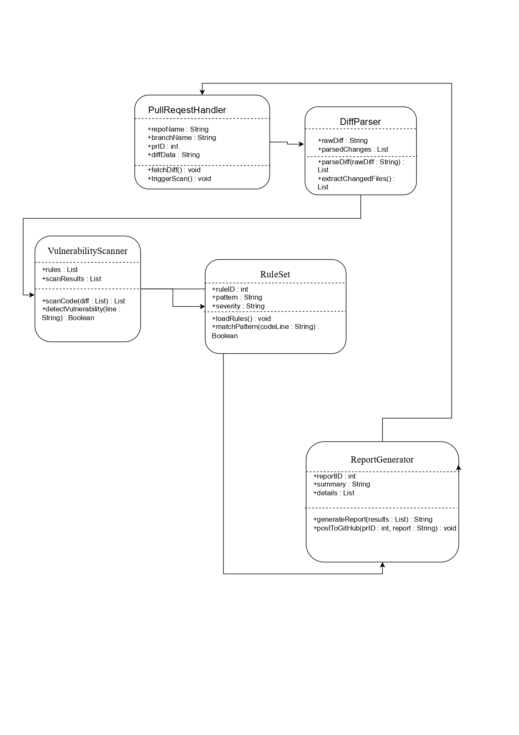
Class Diagram

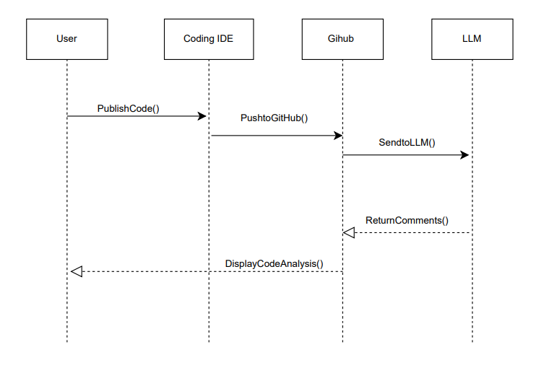
Sequence Diagram

Collaboration Diagram
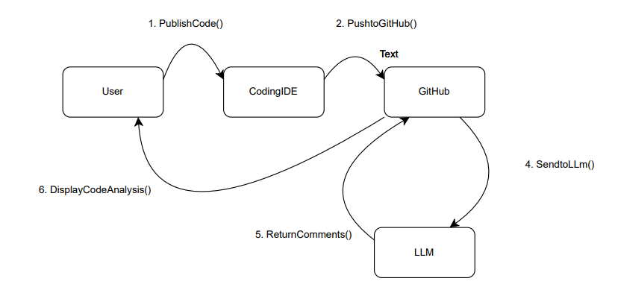

Package Diagram

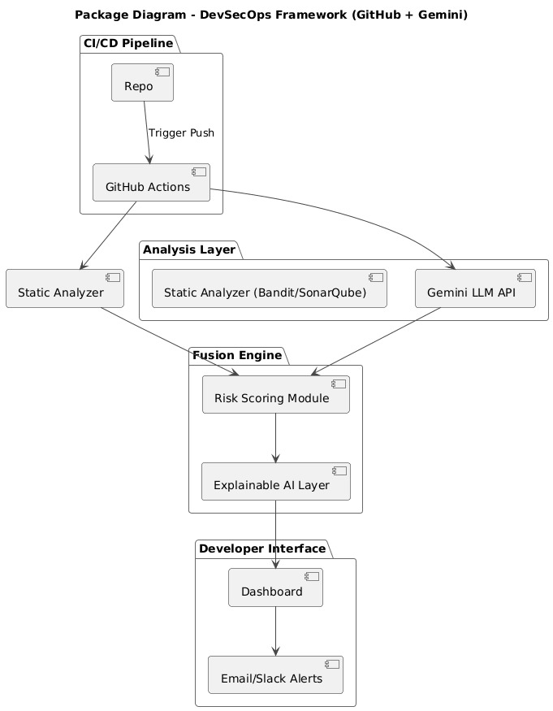

Activity Diagram
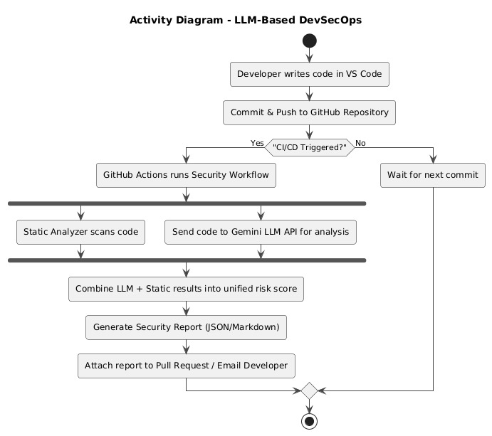

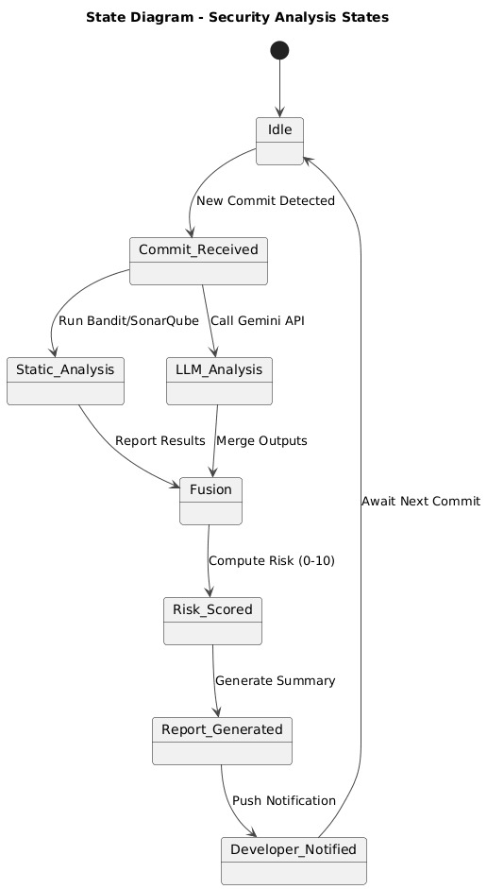

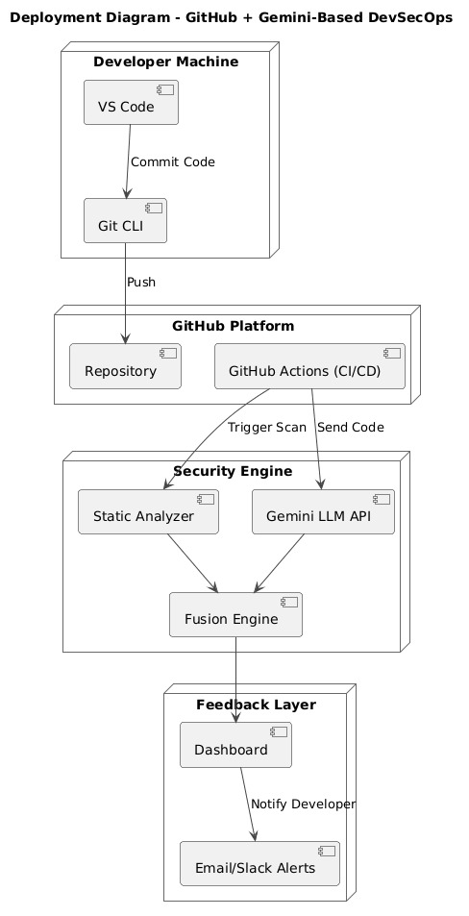

Implementation of Code and GUI

Instead of copying our whole codebase here, please go to attached GitHub link to our project,
Github repository link : https://github.com/ggmu-iitstudentffvg/seproj/tree/main/.github/workflows

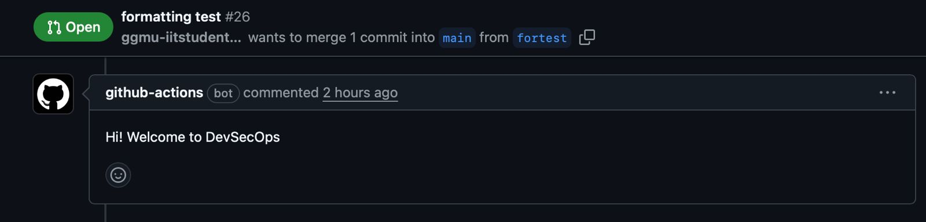
Project screenshots
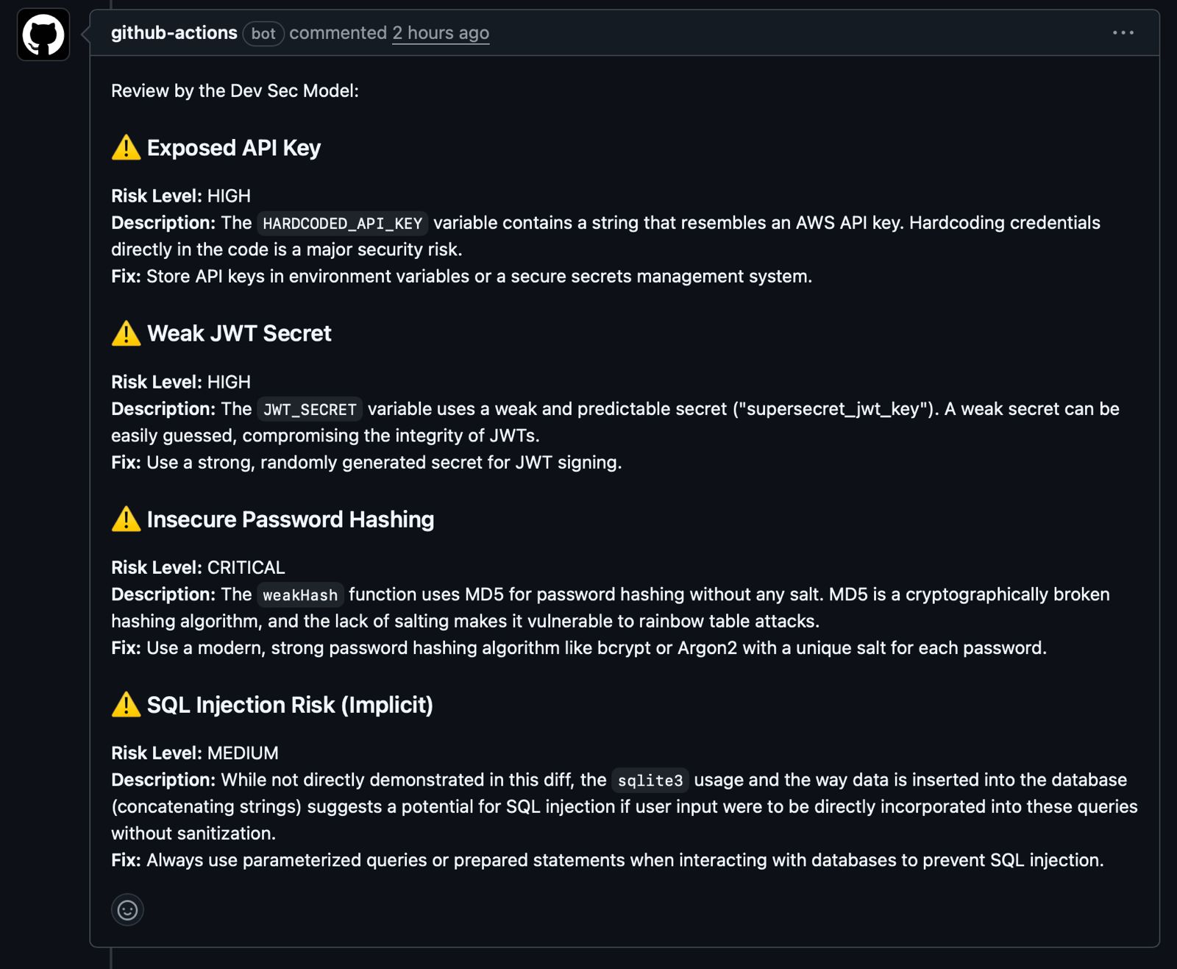

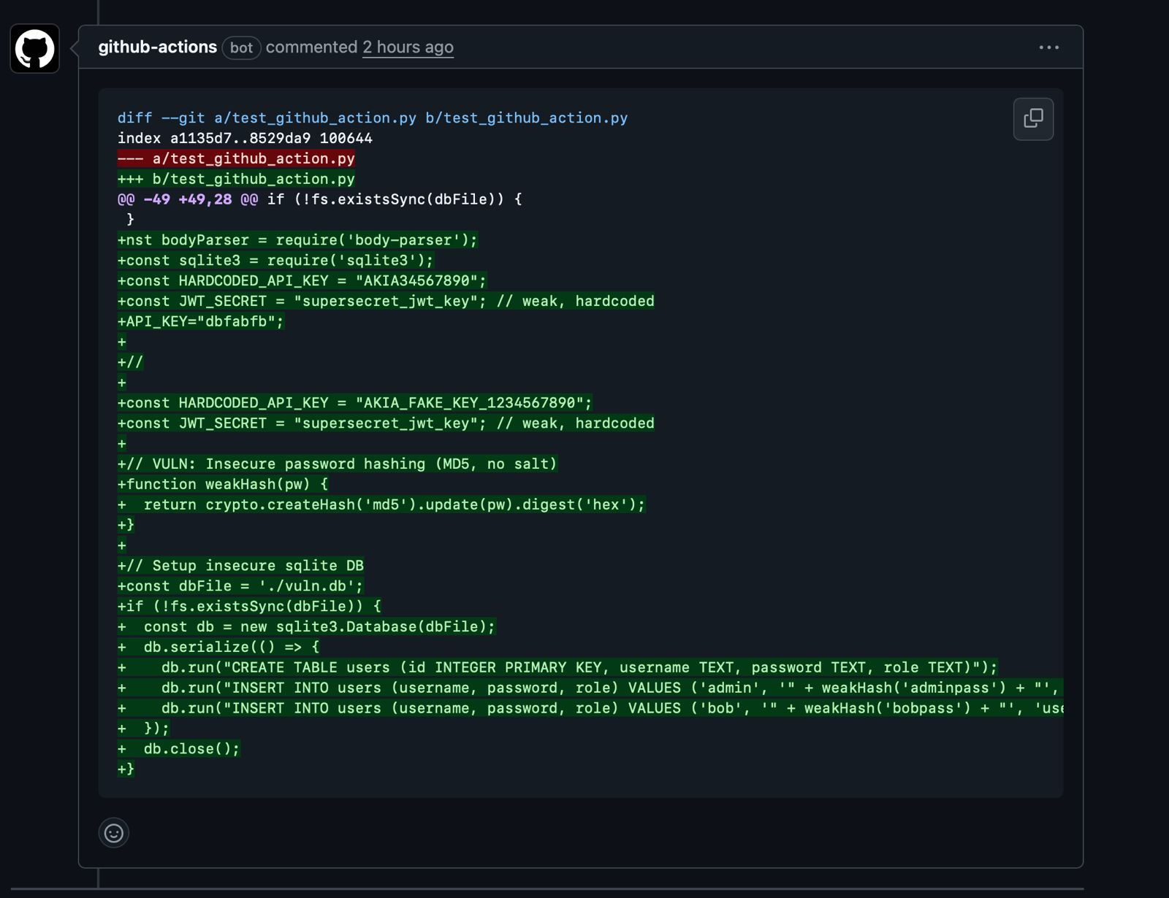
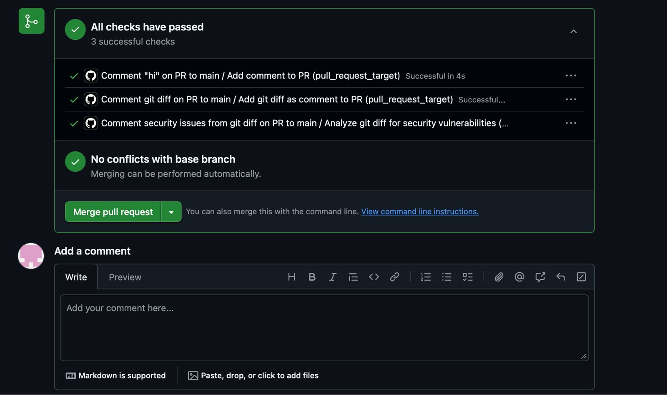
\

Results and Analysis
Results
The LLM-based DevSecOps Platform (LLM-DSO) was developed and successfully integrated into a simulated GitHub CI/CD environment. The key operational outcomes were:
- LLM Integration and Analysis:
  - Successfully established reliable connectivity and abstraction layers for the mandated external LLMs (Google AI Studio, ChatGPT, and Claude AI) to perform code analysis.
  - The LLM analysis module achieved its primary goal of proactively detecting targeted vulnerabilities, including SQL Injection and XSS, by leveraging contextual understanding of the code diff.
  - Demonstrated the ability to generate specific, actionable remediation guidance and suggested code corrections (R-4.2.4) for every detected security alert.
- Performance and Speed:
  - The end-to-end pipeline latency (E2E) for security scanning and report generation consistently met the Max 30 seconds requirement (R-5.1.1), ensuring the check remained synchronous with the CI/CD workflow and did not introduce friction into the developer experience.
  - The time-to-first-token (TTFT) for analysis output was optimized to be below 500 ms, providing developers with near-instantaneous feedback that the scan was running.
- Policy Enforcement:
  - The automated Quality Gate (R-5.5.1) was proven effective by automatically failing the pipeline and blocking the code merge whenever a vulnerability classified as Critical or High severity was detected (R-4.2.6).

Analysis
The project fundamentally changes how security is managed in the development process, moving from a reactive model to a proactive, real-time approach. The comparison below highlights the achieved benefits:
Criterion | Current Situation (Traditional Security Model) | Proposed System Outcome (LLM-DSO)
Security Integration | Security checks occur late (testing phase, deployment). | Shift Left: Security check is integrated automatically on every code push/commit.
Vulnerability Detection | Primarily relies on static pattern matching; struggles with context. | Intelligent Analysis: Uses LLMs for nuanced, contextual detection of complex flaws.
Feedback Latency | Slow; developers often receive security reports hours or days later. | Real-Time: Immediate feedback (within 30 seconds) delivered directly to the Pull Request.
Code Merge Risk | High risk of Critical/High severity bugs entering the main branch. | Zero Tolerance: Critical/High bugs are automatically blocked by the Quality Gate (R-5.5.1).
Remediation Speed | Slow; developers must manually research fixes and rewrite code. | Accelerated: LLM provides immediate, code-specific suggestions, significantly speeding up the fix process.

Conclusion
The LLM-based DevSecOps Platform (LLM-DSO) successfully achieved its core objective: to shift security left and integrate automated vulnerability detection directly into the continuous integration (CI) pipeline.
By leveraging Large Language Models (LLMs) from mandated providers (Google AI Studio, ChatGPT, Claude AI), the system moved beyond simple static analysis, demonstrating the ability to detect and classify complex vulnerabilities, such as SQL injection and XSS, in real time.
Key achievements include:
- Real-Time Enforcement: We met the stringent performance requirement for "real-time" analysis, ensuring the security check completes fast enough to not disrupt the agile developer workflow.
- Actionable Feedback: The system provides immediate, actionable feedback and generated code suggestions directly to the developer via GitHub Pull Request comments, drastically reducing the time needed for remediation.
- Quality Gate: The mandatory Quality Gate successfully enforces security policy by automatically blocking the merge of any code containing Critical or High-Severity vulnerabilities.
- Defined Architecture: The project confirmed all mandatory software engineering deliverables, including the detailed functional requirements (SRS) and the supporting analysis models (ER Diagram, Software and Hardware Flowcharts), ensuring the system has a clear, maintainable architecture.
Overall, the LLM-DSO project demonstrates that integrating intelligent, AI-driven security checks at the start of the development cycle is essential for building safer, cleaner code quickly and efficiently.

